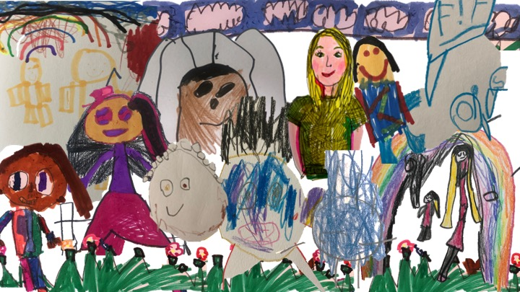
Play Tales: Co-creating stories of childhoodnature play in an urban forest school in London, England.

By Hannah, Wonderboy, Fairy, Miss Daisy, Tinkerbell, Zak, Fatima, Donut and Stickman.
This article is a collaborative exploration of play in a London forest school, conducted by a group of primary school children aged 5-6 years old and a researcher named Hannah from the University of Bath. We (the children and Hannah) acted as "co-inquirers" contributing our thoughts, ideas, and experiences. In the article, we share our experiences of the research and of writing this journal article together as co-authors.
The main aim of the research was to understand how play unfolds in an outdoor setting and the kinds of relationships children form with nature while playing. Our research methods included storytelling, drawing, playing games, and creating a collaborative research journal. We used these activities to express our thoughts and memories of forest school, discussing our interactions with nature and our play.
We end the article by sharing some of our key insights including that play helps us build friendships, brings together our home, school, digital and outdoor worlds and connects us to natural elements with animals, plants and weather. We suggest that adults can learn from and with children, who are experts when it comes to fun, joy and imagination, about the process of play and the ways we can foster relations with nature.

